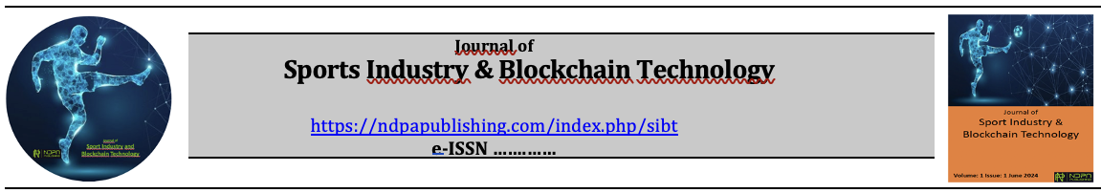

Manuscript Withdrawal Form

Manuscript Title:
……………………………………………………………………………………………………………………………………………………………………………………………………………………………………………………………………………………………..

Reasons for Article Withdrawal:
……………………………………………………………………………………………………………………………..…………………………………………………………………………………………………………………………………………………………………..
Author(s)' Name(s) and Institution(s) (in the order of appearance in the article)

Title | Full Name | Institution | Signature

As the corresponding author, on behalf of all authors;
I acknowledge and commit that I will not submit our study to another journal for review until the request for withdrawal of our study submitted to the Journal of Sports Industry & Blockchain Technology (JSIBT)) is approved by the Editorial Board. I will work in full cooperation with the Editorial Board for the withdrawal process.

 | Corresponding Author | Signature | Date

