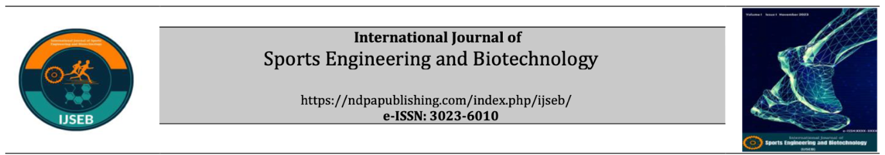

Copyright Agreement

Title:

Submission Date:

The author(s) agrees that:

The manuscript submitted is his/her/their own original work and has not been plagiarized from any prior work. All authors participated in the work in a substantive way and are prepared to take public responsibility for the work. All authors have seen and approved the manuscript as submitted. The manuscript has not been published and is not being submitted or considered for publication elsewhere. The text, illustrations, and any other materials included in the manuscript do not infringe upon any existing copyright or other rights of anyone. International Journal of Sports Engineering and Biotechnology (IJSEB), will publish the content under Creative Commons Attribution 4.0 (CC-BY 4.0) International license that gives permission to copy and redistribute the material in any medium or format, transform and build upon the material by providing appropriate credit to the original research. I/We indemnify IJSEB and the Editors of the Journals, and hold them harmless from any loss, expense or damage occasioned by a claim or suit by a third party for copyright infringement, or any suit arising out of any breach of the foregoing warranties as a result of publication of my/our article. I/We also warrant that the article contains no libelous or unlawful statements and does not contain material or instructions that might cause harm or injury.
This Copyright Agreement Form must be signed/ratified by all authors. Separate copies of the form (completed in full) may be submitted by authors located at different institutions; however, all signatures must be original and authenticated.

Author(s) and signature(s) of all author/s in order:

Responsible/Corresponding Author: Signature(s) Date
1. ………………………  2. ………………………  3. ………………………  4. ………………………  5. ………………………  6. ………………………  7. ………………………  8. ………………………  9. ………………………  10. …………………… | …………………………….  ……………………………  ……………………………  ……………………………  ……………………………  ……………………………  ……………………………  ……………………………  ……………………………  …………………………… | …………………………….  ……………………………  ……………………………  ……………………………  ……………………………  ……………………………  ……………………………  ……………………………  ……………………………  ……………………………

