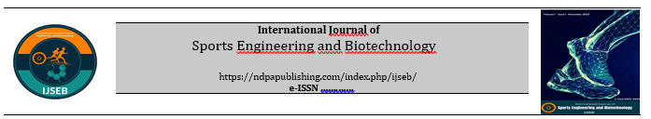

Manuscript Withdrawal Form

Manuscript Title:
……………………………………………………………………………………………………………………………………………………………………………………………………………………………………………………………………………………………..

Reasons for Article Withdrawal:
……………………………………………………………………………………………………………………………..…………………………………………………………………………………………………………………………………………………………………..
Author(s)' Name(s) and Institution(s) (in the order of appearance in the article)

Title | Full Name | Institution | Signature

As the corresponding author, on behalf of all authors;
I acknowledge and commit that I will not submit our study to another journal for review until the request for withdrawal of our study submitted to the International Journal of Disabilities Sports and Health Sciences (IJSEB) is approved by the Editorial Board. I will work in full cooperation with the Editorial Board for the withdrawal process.

 | Corresponding Author | Signature | Date

