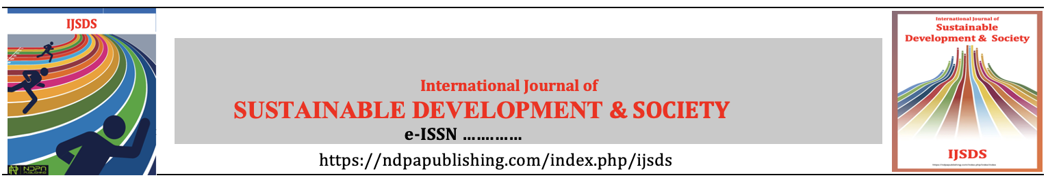

Copyright Agreement

/ /2024
Title:

Submission Date:

The undersigned authors transfer the ownership of copyright to International Journal of Sustainable Development & Society (IJSDS) should their work be published in IJSDS. We declare that the article is original, has not been submitted for publication in other journals and has not already been published elsewhere. All authors have essentially participated in this study, assumed all responsibilities for this study, have seen and approved the final version of the article.
Best Regard.

Author(s) and signature(s) of all author(s) in order:

Author(s) Signature(s) Date
1. ………………………  2. ………………………  3. ………………………  4. ………………………  5. ………………………  6. ……………………… | …………………………….  ……………………………  ……………………………  ……………………………  ……………………………  …………………………… | …………………………….  ……………………………  ……………………………  ……………………………  ……………………………  ……………………………

