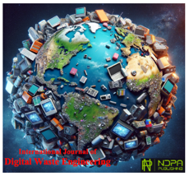 |  | 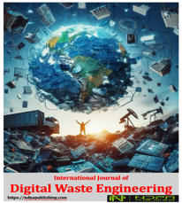
International Journal of
Digital Waste Engineering e-ISSN …….……
 | https://ndpapublishing.com/index.php/

Copyright Agreement

Title:

Submission Date:

The undersigned authors hereby agree that statements, opinions and data contained in all publications are solely those of the individual author(s) and contributor(s) and not of International Journal of Digital Waste Engineering (IJDWE) and/or the editor(s). IJDWE and/or the editor(s) disclaim responsibility for any injury to people or property resulting from any ideas, methods, instructions or products referred to in the content.
• For all articles published in International Journal of Digital Waste Engineering, copyright is retained by the authors. Articles are licensed under an open access Creative Commons CC BY 4.0 license, meaning that anyone may download and read the paper for free. In addition, the article may be reused and quoted provided that the original published version is cited.
For further details of the license CC BY 4.0, please see
https://creativecommons.org/licenses/by-nc/4.0/
• The authors retain all patent and other proprietary rights to the article, including copyright.
• In addition to the non-exclusive rights the Publisher has under the CC BY 4.0 license, this agreement also authorizes the Publisher to permit the commercial use of the content as well aspublication, republication in electronic and print format in the journal and distribution of the content.
Best Regard.
Author(s) and signature(s) of all author(s) in order:

Author(s) Signature(s) Date
1. ………………………  2. ………………………  3. ………………………  4. ………………………  5. ………………………  6. ………………………  7. ………………………  8. ………………………  9. ………………………  10. …………………… | …………………………….  ……………………………  ……………………………  ……………………………  ……………………………  ……………………………  ……………………………  ……………………………  ……………………………  …………………………… | …………………………….  ……………………………  ……………………………  ……………………………  ……………………………  ……………………………  ……………………………  ……………………………  ……………………………  ……………………………

